If your activity will utilize the Multi-Presentation Evaluation, complete this form and upload it to the application. Click here to complete the Multi-Presentation Build Evaluation Form. If you have questions or want to discuss the options / logistics of a multi-presentation evaluation, contact averacontinuingeducation@avera.org.
If you are working with an event consultant on a conference or larger activity, we recommend you go through this form with your event consultant prior to submitting the application.
Presenter
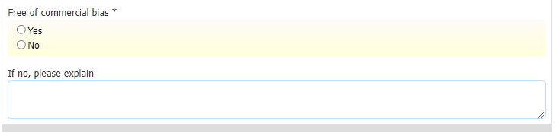
Presenter(s) not evaluated

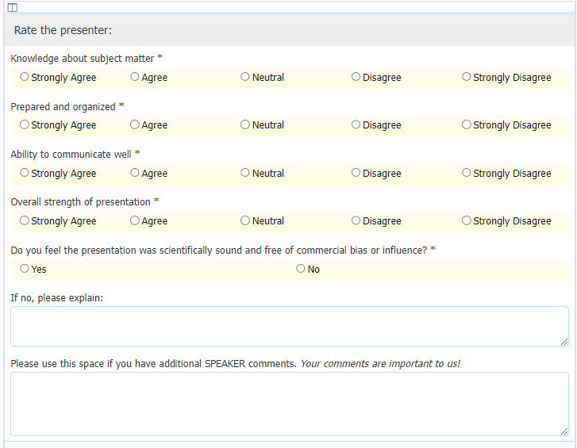
Presenter(s) evaluated

Objectives
Objectives not evaluated - recommended

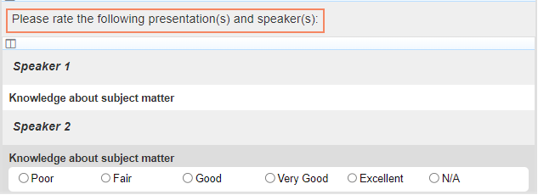
Objectives evaluated (must place faculty name behind the objection)

Commitment to Change
Commitment to change questions are designed to help committee members evaluate the areas of practice that the participants intend to change as a result of the activity.
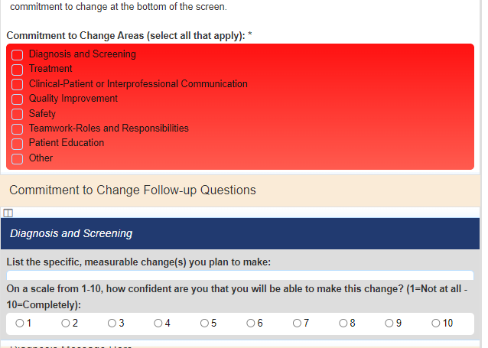

Demographics*

*If there is a group that is not listed and you want to know evaluate their responses, indicate this in your planning form.

Non-negotiable questions

The following questions are required for Avera’s accreditation. To have these removed, contact averacontinuingeducation@avera.org prior to submitting the application.

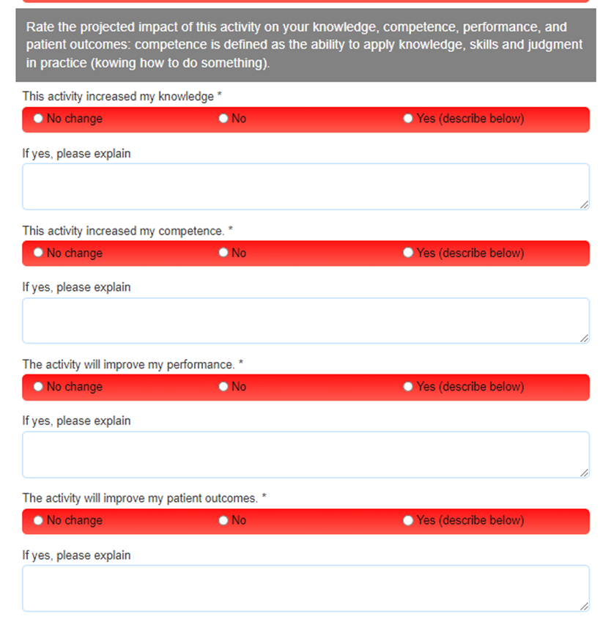
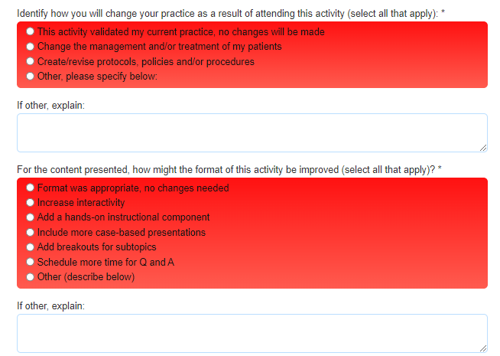

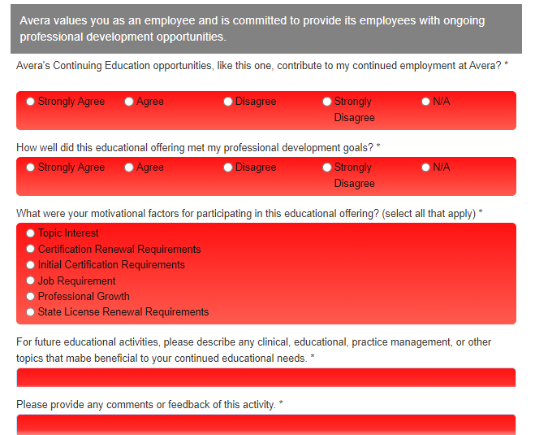

Multi-Presentation Evaluation Build Form

Answer the questions by choosing a presenter template, objective template and/or a commitment to change template when designing the evaluation.

Name of Activity: Click or tap here to enter text.

Date of Activity: Click or tap to enter a date.

Presenter
☐ No, do not evaluate individual presenter(s) ☐ Yes, evaluate individual presenter(s)

Objectives
☐ No, do not evaluate objectives ☐ Yes, evaluate objectives
(must add presenter name behind objection)

Commitment to Change (CTC)
☐ No, do not include CTC questions ☐ Yes, include CTC questions

Demographics
List additional professions you want to evaluate? Click or tap here to enter text.

Notes/Comments Click or tap here to enter text.

