ASWB ACE Reference:
Course topics must clearly fall within the scope of practice for social workers and be directly applicable to social work practice, relating to one or more of the following social work educational areas:
- GENERAL: Theories and concepts of human behavior in the social environment
- CLINICAL: Social work practice, knowledge, and skills
  - Social work research, programs, or practice evaluations
  - Social work agency management or administration
  - Development, evaluation, and implementation of social policy
  - Social work generalist practice
  - Social work clinical practice
- CULTURAL COMPETENCY: Diversity and social justice
- ETHICS: Social work ethics

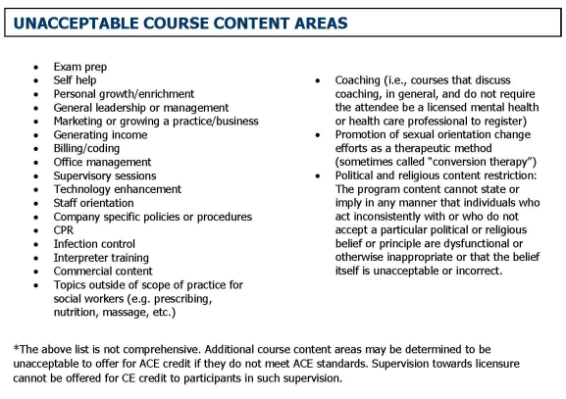

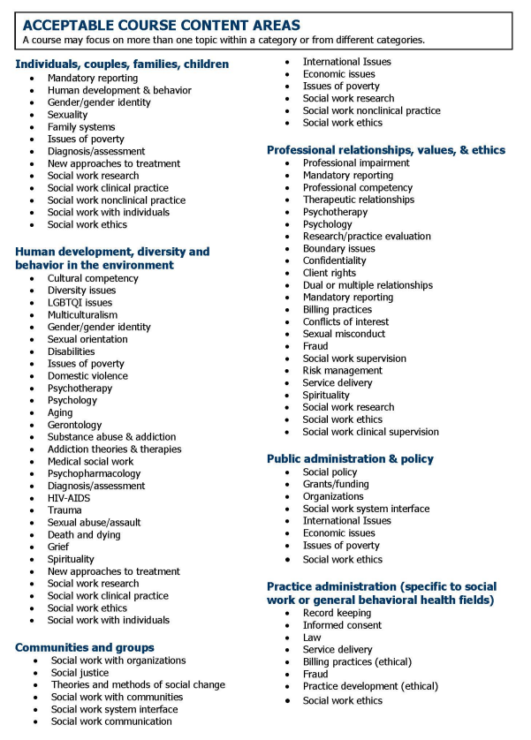
References: ASWB ACE Handbook (https://www.aswb.org/wp-content/uploads/2022/07/ACE-Handbook-8.2022.pdf)

